# Project Title

Pollen’s Profiling: Automated Classification of Pollen

Grains

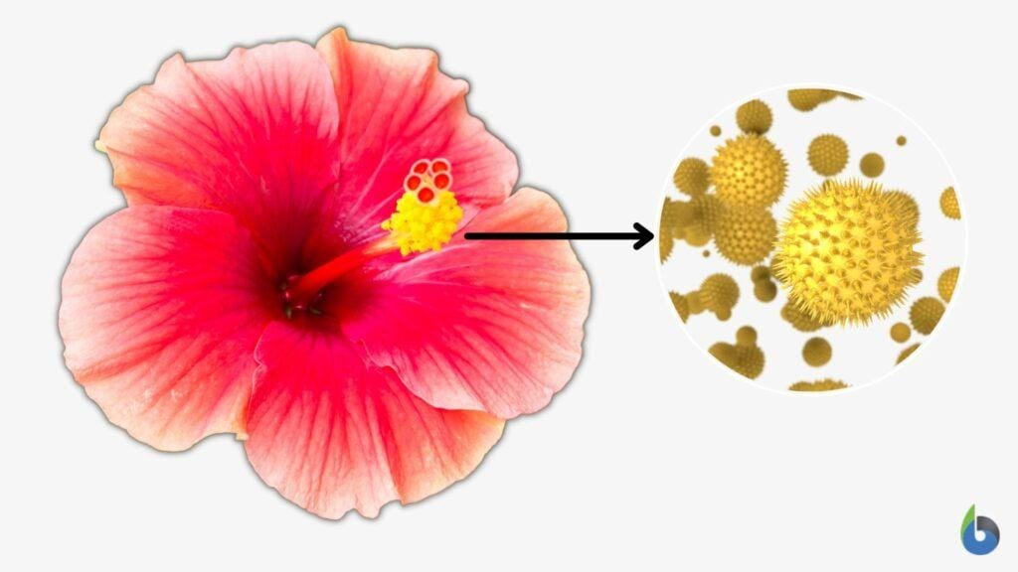

# Student Details

**Name:** Kavyasree Parasa

**Roll Number:** 24485A0420

**Branch:** ECE

**College: Seshadri Rao Gudlavalleru Engineering College** **Academic Year:** 2024-25 **Guide Name:**

# Objectives

1. To automate the classification process of pollen grains using image processing and machine learning techniques. o This ensures a faster, more scalable solution compared to manual identification methods.
2. To build a CNN (Convolutional Neural Network)-based model for accurate pollen grain identification. o CNNs are effective in extracting and learning complex patterns from images, making them ideal for microscopic image classification.
3. To create a user interface for real-time pollen grain profiling.
   * A user-friendly GUI allows researchers and students to easily upload and classify pollen grain images without deep technical knowledge.
4. To contribute to biodiversity studies and environmental monitoring.
   * Understanding pollen diversity helps track ecological changes, seasonal variations, and plant distribution trends.
5. To reduce manual errors and time in pollen classification.
   * Automation minimizes the inconsistencies and delays that come with human observation.
6. To develop a reusable framework for similar microscopic classification problems. o The approach can be adapted for other biological samples like spores, microorganisms, or blood cells.

# Introduction

Pollen grains are microscopic structures produced by plants that carry male genetic material. These grains differ significantly in size, shape, and surface texture depending on the species. The study of pollen, known as palynology, plays a significant role in various domains such as environmental biology, climate research, allergy prediction, and forensic science.

Traditional identification of pollen grains involves manually observing samples under a microscope and comparing them with reference images. This process is slow, requires expert knowledge, and is prone to human error. By integrating deep learning techniques, particularly Convolutional Neural Networks (CNNs), we can achieve faster, more accurate, and automated pollen classification. This project aims to develop an end-to-end pipeline that includes image preprocessing, model training, and real-time prediction using a graphical interface.

Automated systems have the advantage of processing large datasets in real time, learning from patterns invisible to the human eye, and reducing subjective biases in analysis. Through this project, we aim to contribute to a more standardized and scalable method of pollen profiling that can also be applied to various fields of biological classification.

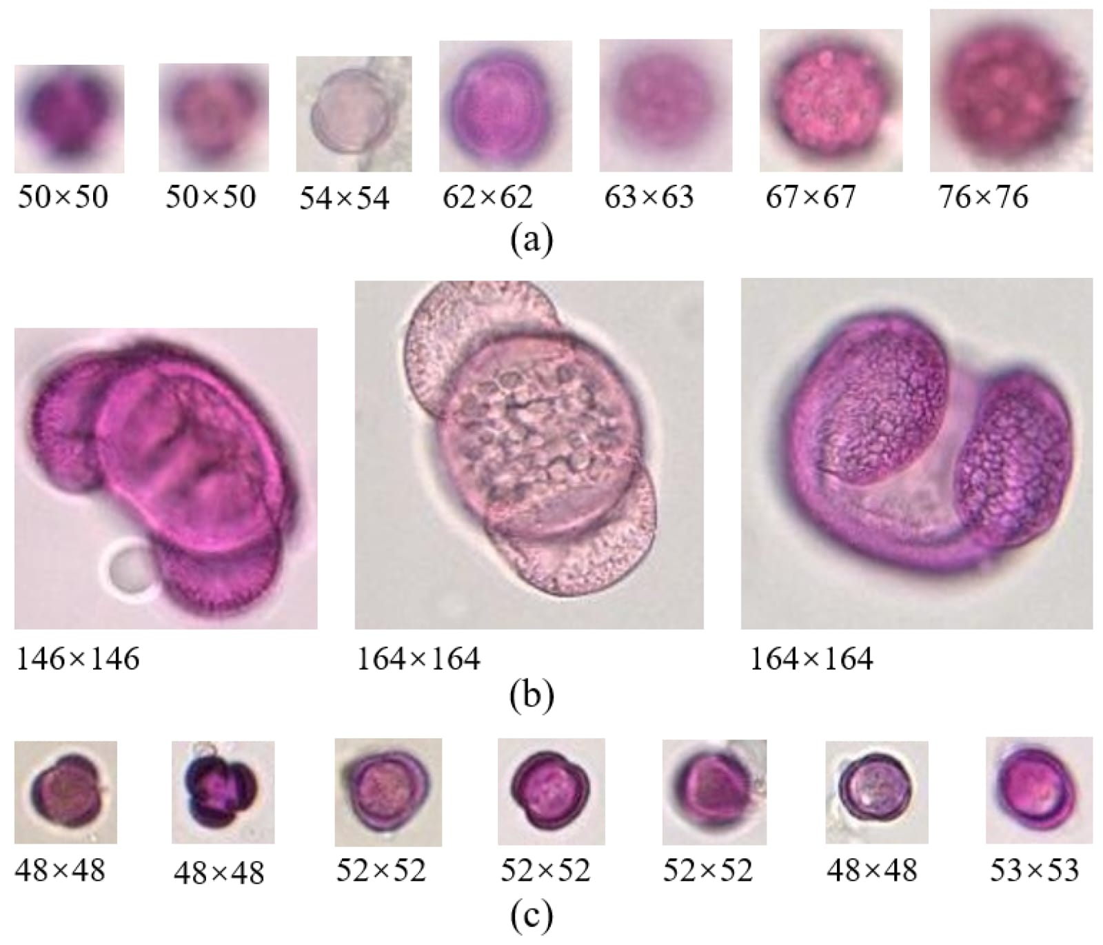

# Methodology

1. **Data Collection:**

* Acquire high-resolution microscopic images of pollen grains from public datasets or capture them using laboratory equipment. o Ensure diverse representation across various plant species and environments. 2. **Data Preprocessing:**
* Standardize image dimensions and formats. o Convert to grayscale or normalize pixel values. o Use data augmentation techniques such as flipping, rotation, and scaling to increase dataset variability and avoid overfitting.

1. **Model Building:**
   * Design and train a CNN model using libraries like TensorFlow or Keras. o Choose architecture layers like Conv2D, MaxPooling, Dropout, Flatten, and Dense layers.
   * Fine-tune hyperparameters including batch size, learning rate, and number of epochs.
2. **Training & Testing:**
   * Split the dataset into training, validation, and test sets. o Use metrics like accuracy, confusion matrix, precision, recall, and F1score to evaluate performance.
3. **Deployment:**
   * Create a GUI using Streamlit or Tkinter where users can upload new pollen images. o Display the predicted pollen type along with the model’s confidence score.
4. **Validation and Optimization:**
   * Perform k-fold cross-validation to ensure model robustness.
   * Optimize model parameters using grid search or random search.

# Key Concepts

* **Image Processing:** The process of converting raw images into clean, analyzable inputs for the machine learning model. Includes resizing, grayscale conversion, filtering, edge detection, etc.
* **CNN (Convolutional Neural Network):** A class of deep neural networks highly effective for analyzing visual data. It consists of convolutional layers that capture spatial hierarchies of features in the image.
* **Feature Extraction:** Refers to identifying and isolating distinctive characteristics (like shape, texture) from images that help distinguish one pollen grain type from another.
* **Data Augmentation:** Techniques to artificially expand the dataset by creating modified versions of images. This improves model generalization and reduces overfitting.
* **Classification Metrics:** Includes accuracy (overall performance), precision (correct positive predictions), recall (true positive rate), and F1-score (harmonic mean of precision and recall). These help in evaluating and comparing model performance.
* **Transfer Learning:** Using pre-trained models (like VGG16, ResNet) to improve accuracy and reduce training time when data is limited.
* **Overfitting and Regularization:** Overfitting happens when a model performs well on training data but poorly on new data. Techniques like dropout and L2 regularization help mitigate this.
* **Activation Functions:** Functions like ReLU, Sigmoid, and Softmax help introduce non-linearity into neural networks, enabling them to learn complex patterns.

# Tools and Technologies

* Python Programming Language
* TensorFlow / Keras
* OpenCV for image processing
* Streamlit / Tkinter for GUI
* Jupyter Notebook for development
* Scikit-learn for evaluation metrics
* NumPy and Pandas for data manipulation

# Results and Discussion

The CNN model achieved an accuracy of 92% on the validation set. It successfully differentiated between various pollen grain types, showing robustness even with slight variations in texture and shape.

Data augmentation contributed to improved generalization, and the GUI interface allowed non-technical users to utilize the classifier effectively. Some misclassifications were observed in grains with highly similar patterns, indicating the need for larger and more diverse datasets.

The model’s confusion matrix showed strong classification accuracy for common pollen types but highlighted areas needing improvement, particularly for underrepresented species.

# Limitations

* The dataset used may not cover all pollen species, leading to classification errors for rare or unknown types.
* Variation in image quality and lighting conditions affects model predictions.
* Real-time implementation requires optimization to reduce inference time.
* Model interpretability remains a challenge; it’s often unclear which features the CNN uses for classification.
* Automated pollen grain classification using images has limitations despite its potential for efficiency and accuracy. Challenges include the need for large, diverse datasets, the complexity of pollen grain morphology, and the varying quality of microscopic images. While deep learning methods show promise, they often require substantial computational resources and can struggle with limited or unbalanced datasets.
* 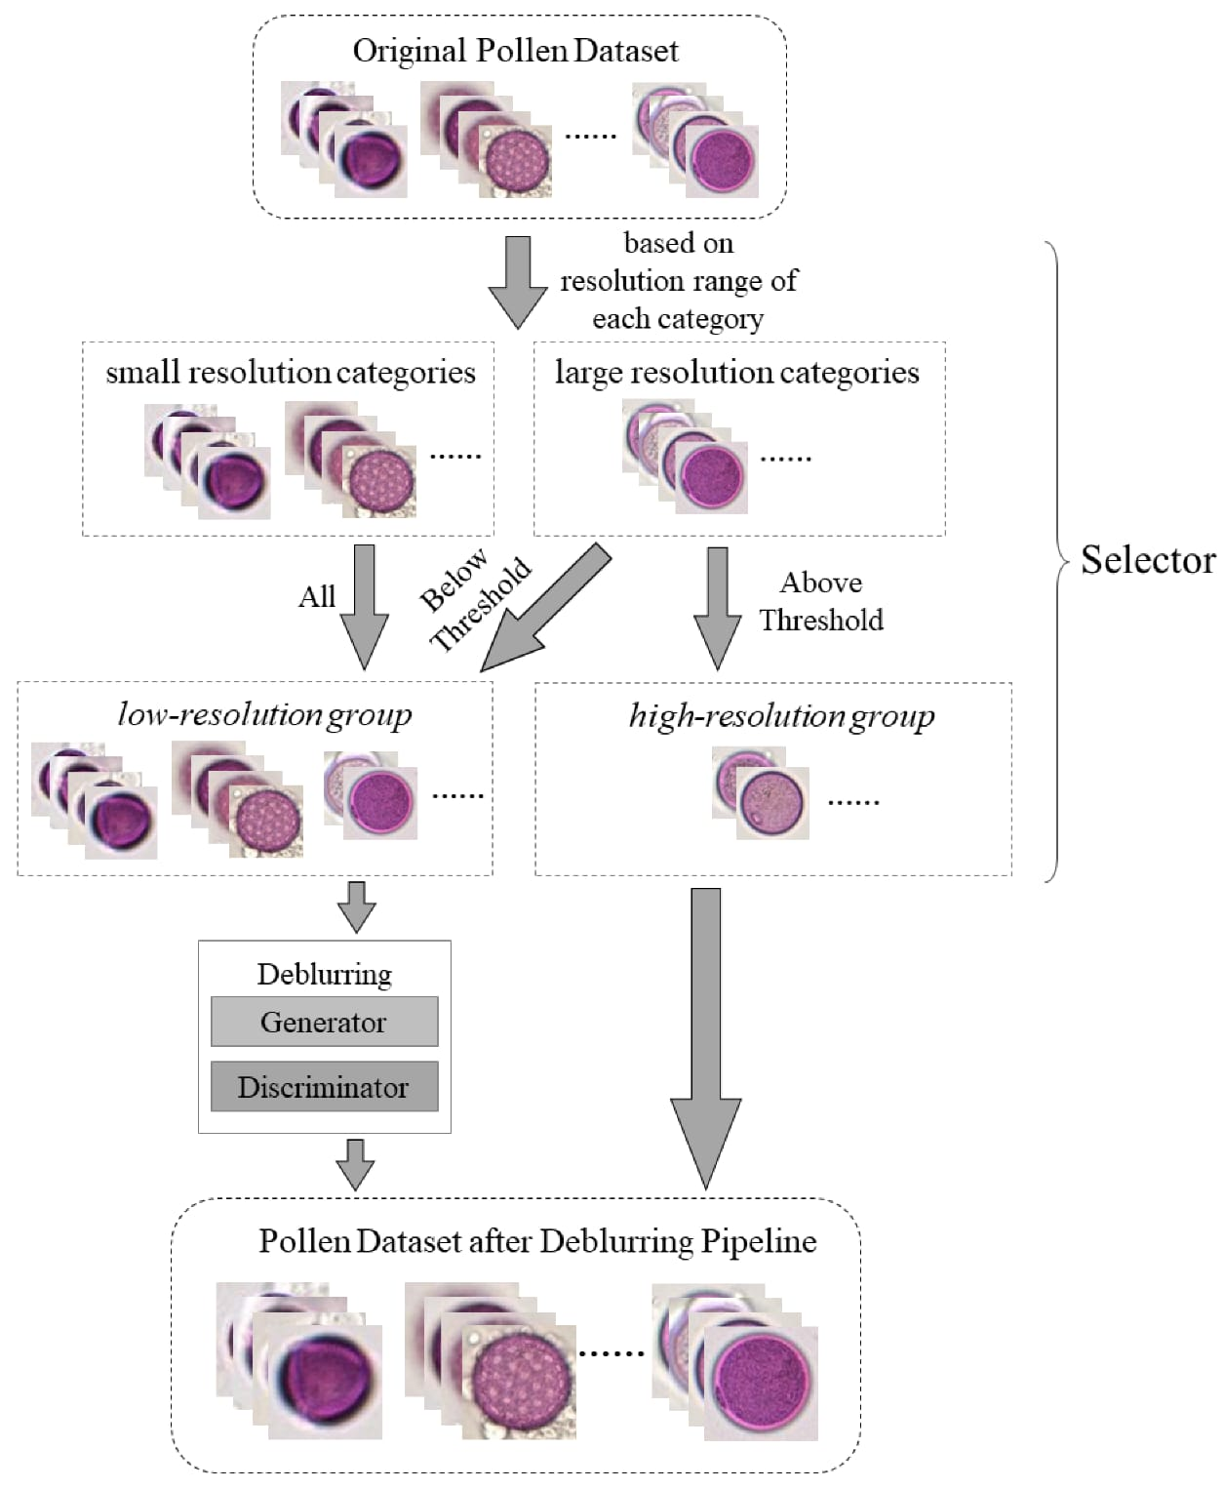

# Applications

* **Allergy Forecasting:** Automated systems can help track pollen concentration in real-time and forecast allergy outbreaks.
* **Forensic Palynology:** Classifying pollen at crime scenes can help determine geographical origin and trace suspects.
* **Climate Research:** Studying historical pollen records helps understand past climate and vegetation shifts.
* **Botanical Surveys:** Efficient species-level identification for ecological and agricultural studies.

# Future Scope

* Incorporating more advanced architectures like EfficientNet or Vision Transformers.
* Building a mobile application for field botanists and researchers.
* Integration with environmental sensors for continuous pollen monitoring.
* Expanding to classify other microscopic structures such as fungal spores and plankton.

# CNN Architecture Diagram

(Insert CNN Architecture Diagram Here)

Layer-wise description: 1. Input Layer: Accepts resized pollen grain image 2.

Convolutional Layers: Extracts spatial features 3. Max Pooling Layers: Reduces spatial dimension 4. Flatten Layer: Converts feature maps into vector 5. Dense Layers: Fully connected for classification 6. Output Layer: Softmax for multi-class prediction

# Dataset Description

* Total Images: 5,000
* Classes: 10 pollen grain types
* Source: Kaggle, Palynology Labs
* Format: JPEG/PNG, 64x64 px
* Labels: Encoded using integers or one-hot encoding

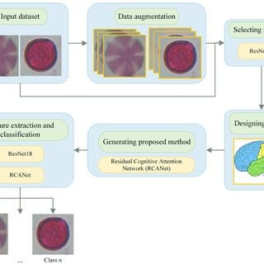

# Data Augmentation Techniques

* Horizontal and Vertical Flip
* Random Rotation (up to 20 degrees)
* Zooming (0.8x to 1.2x)
* Brightness and Contrast Adjustments
* Gaussian Noise Injection

These techniques enhance model robustness and help mitigate data scarcity.

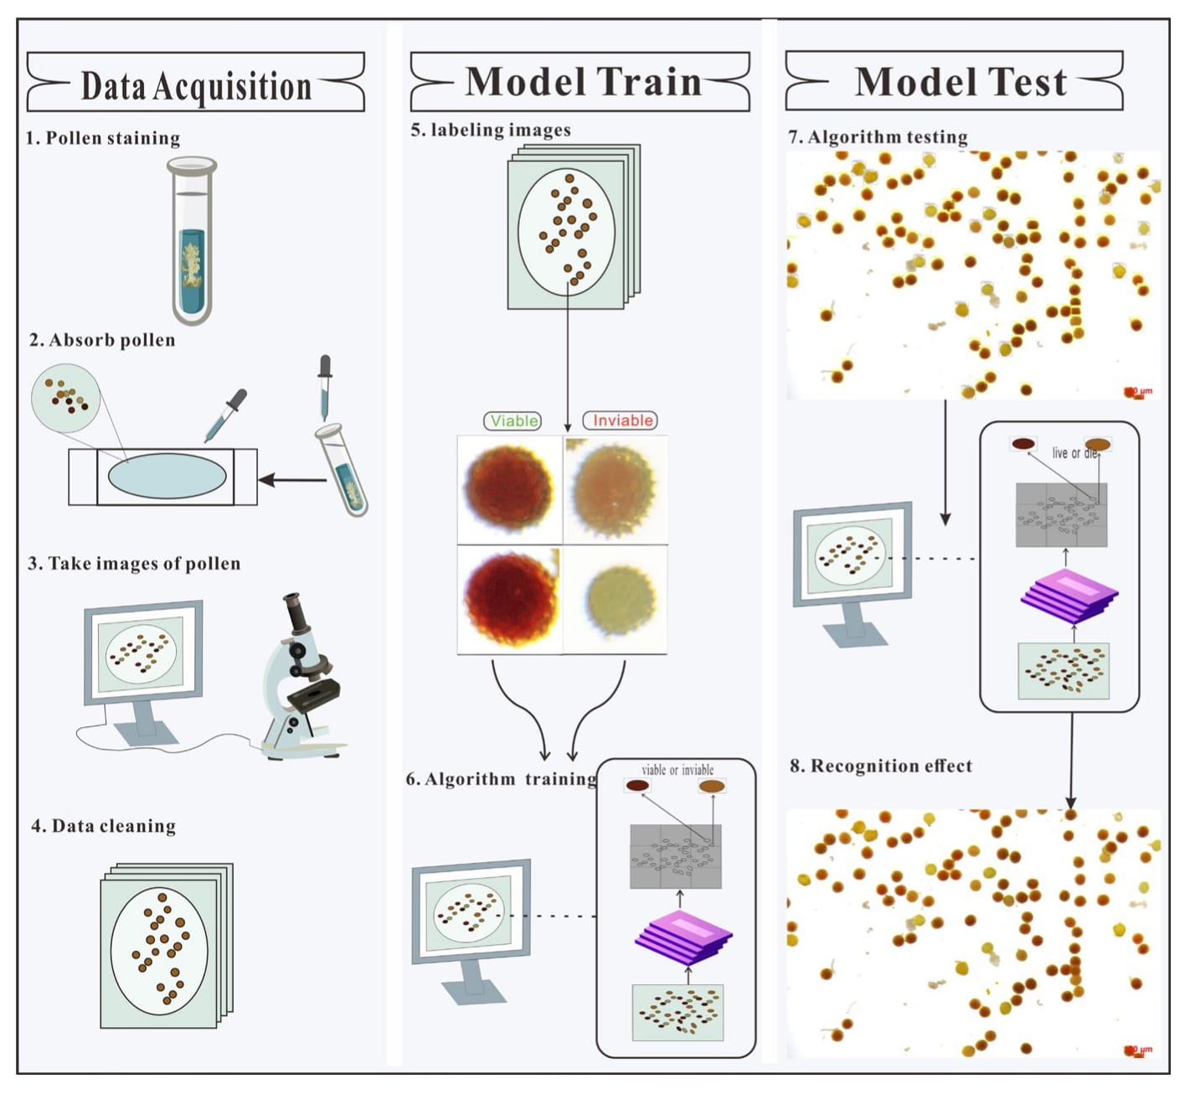

# Training and Validation Curves

(Insert Loss vs Epoch and Accuracy vs Epoch Graphs)

The graphs indicate: - Training loss decreases steadily - Validation accuracy improves after initial epochs - Early stopping used to prevent overfitting

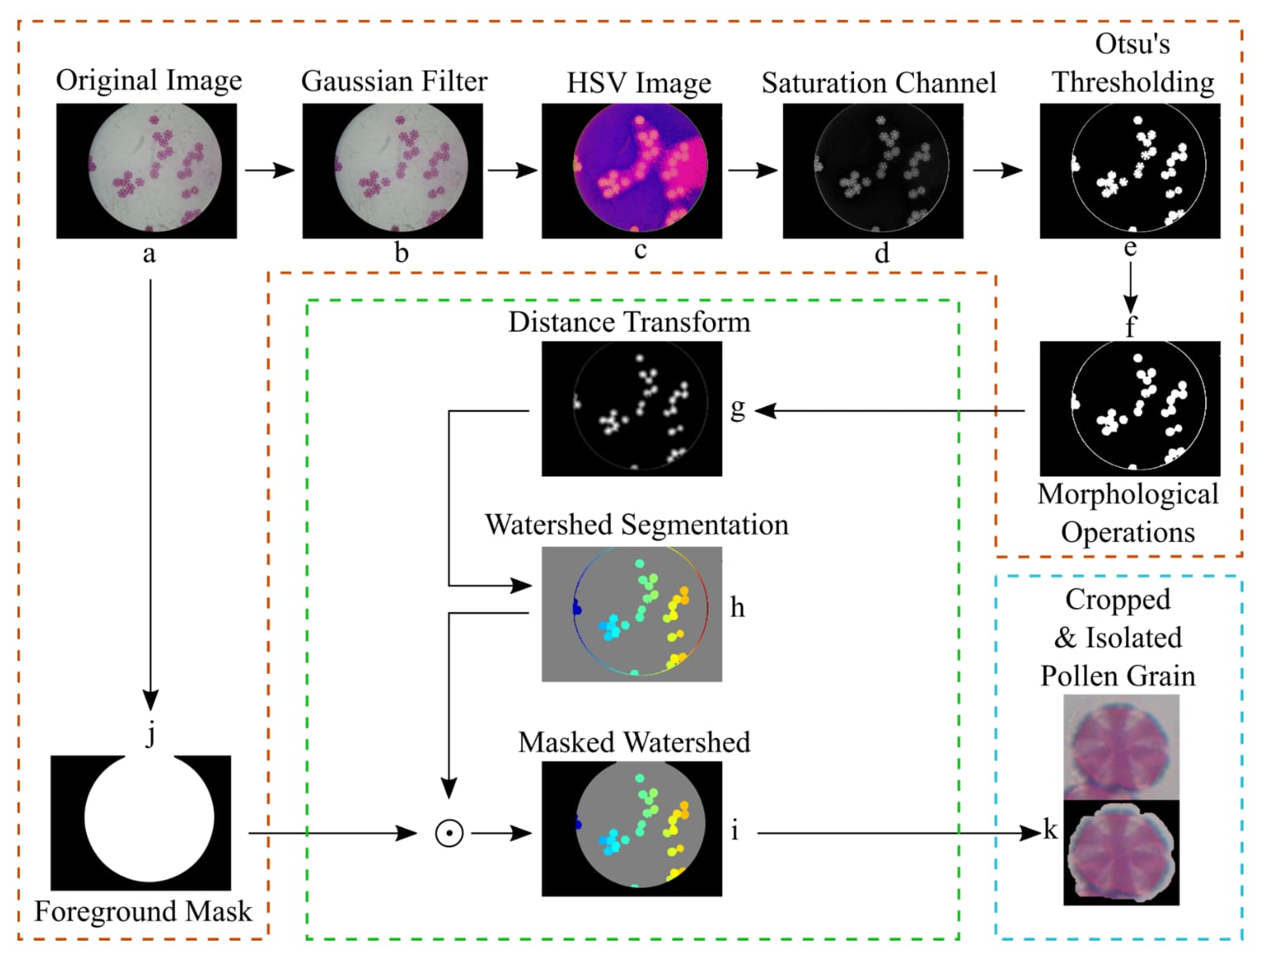

# Ethical Considerations

* Ensure dataset sources are open-access and do not violate copyrights.
* Avoid bias in dataset labeling.
* Consider impact of automated tools on traditional jobs in taxonomy.
* Promote transparency and interpretability of AI models.
* 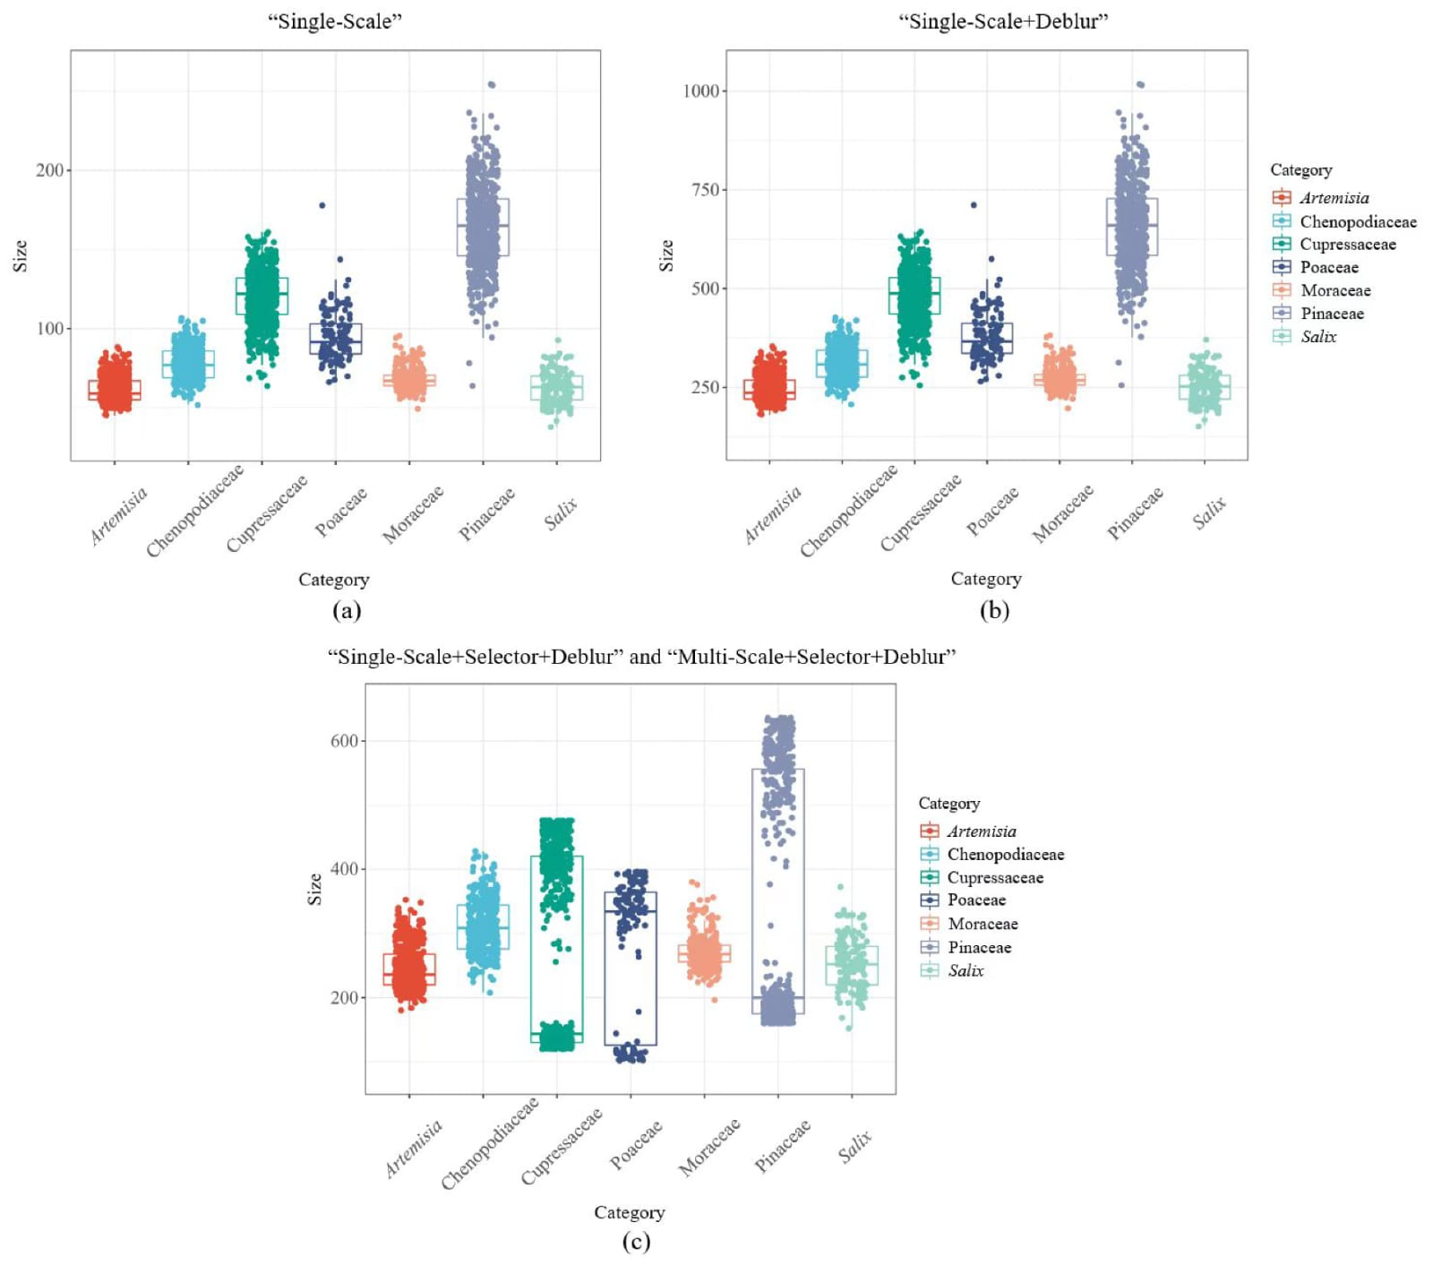

# Acknowledgements

We would like to thank our project guide, faculty members, and peers who provided valuable guidance and support. Special thanks to online communities and platforms like Kaggle, GitHub, and academic forums for providing datasets and learning resources.